

Travel Experts System

Software Version: 1.0

March 21, 2019

Installation and Deployment Guide template information

**Document Responsibilities**

The Installation and Deployment Guide is first created in the Deployment process step. Responsibilities for document creation and content are shown in the RACI[1] chart below:

|  |  |  |  |
| --- | --- | --- | --- |
| **Project Manager** | **Lead Developer** | **Systems Admin** | **Business Analyst** |
| A | R | I | C |

**Combining or splitting documents**

Documentation required by the process may be physically combined into fewer documents or split up into more documents in any way which makes sense to the project provided that all topics required by all the standard templates are present.

If information is split across several documents, all related documents shall be included in the reviews and sign off. For example, when installation and deployment instructions are in separate documents, the documents shall undergo the same preparation, review, and approval activities as well as review to ensure consistency of technical information among the component documents.

**Reviews**

The Installation and Deployment Guide is to be reviewed by the Technical Lead, and the Test Lead. At a minimum the review should ensure that the Installation and Deployment Guide is technically correct and can be used to install and deploy the software or system in the target environment, resulting in a working and usable system.

**Approvals/Signoffs**

The Installation and Deployment Guide is usually a deliverable component of the software solution. It is reviewed and bugs may be logged against it. But it is not approved or signed off unless required by the client scope/contract.

Installation Guide guidelines

**Acknowledgements**

This document may refer to documents in Adobe® Acrobat® Portable Document Format (PDF). (Adobe® and Acrobat® are registered trademarks of Adobe Systems Incorporated.)

This document may refer to use of products from open source Apache web server, MariaDB, PHP, and Perl.

**Guidelines for revising this document**

This document is prepared using Microsoft Word. The Arial 11 point font is used.

Features of Word can be used to automatically maintain section numbers, table and figure numbers, and fields for information that appears frequently throughout the document.

This document is set up with margins of 0.75 inches on all sides. This setting will allow the document to be printed on both US Letter and European A4 paper sizes without reformatting.

This document contains comments to the author with guidelines on using or revising the document. To view this information, turn on the Review features of Word to show the Final Showing Markup view.

Ownership and revision

This is owned and controlled by the project’s Project Manager. After a baseline of this document is published, the Technical Lead shall ensure that it is placed under change control.

Each change or revision made to this Installation Guide Document shall be summarized in “Revision history” section of this document.

Contents

Installation Guide information ii

Installation Guide guidelines iii

Contents iv

1 Introduction 1-1

1.1 Purpose 1-1

1.2 Revision history 1-1

1.3 Intended audience and reading suggestions 1-1

1.4 Technical project stakeholders 1-1

1.5 References 1-1

1.6 Definitions, acronyms and abbreviations 1-2

2 Server Configurations 2-1

2.1 Server 1 (Database) 2-1

2.1.1 Roles, Features, and Packages 2-1

2.1.2 Installation 2-1

2.1.3 Configured Values 2-8

2.2 Server 2 (Web Application) 2-8

3 Testing the Website 3-1

4 Troubleshooting 4-1

# Introduction

## Purpose

The purpose of this is to describe in technical terms the steps necessary to install the software and make it operational.

## Revision history

The Revision history table shows the date, changes, and authors who have worked on this document.

| Version/Change request number | Version date | Description of changes | Author |
| --- | --- | --- | --- |
| 1.0 | 03/22/2019 | First Draft | Connie, Fred, Peng, Wei |

## Intended audience and reading suggestions

This is intended for the class instructor, Mostafa Mohamed.

It is intended that any relevant instructors can read this document and understand how to install and deploy the software.

## Technical project stakeholders

This section provides a list of all known stakeholders with an interest in the project.

| Name | E-mail address | Phone | Role |
| --- | --- | --- | --- |
| Peng Jiang |  |  | Lead Developer, Front-end Dev |
| Connie He |  |  | Systems Administrator, Back-end Dev |
| Wei Feng |  |  | Business Analyst, Dev |
| Frederick Fernandez |  |  | Project Manager, Dev |

## References

| Reference No. | Document | Author(s) |
| --- | --- | --- |
| REF-1 | [Download XAMPP with PHP 7.3.3, 7.2.16 & 7.1.27](https://www.apachefriends.org/index.html) | Apache |

## Definitions, acronyms and abbreviations

| Term | Definition |
| --- | --- |
| Administrator | This is anyone from the client that has been given administrative rights in the Travel Experts System |

# Server Configurations

## Server (Database)

Installation of this product is supported on the following operation systems and versions:

* MariaDB

### Roles, Features, and Packages

**Packages**

The following software packages must be installed on the operating system prior to installation of the software:

* XAMPP MariaDB (see REF-1)
  + Database Engine
  + Connectivity Components
  + Management Tools

### Installation

Server Installation:

Install XAMPP in C:\ folder.



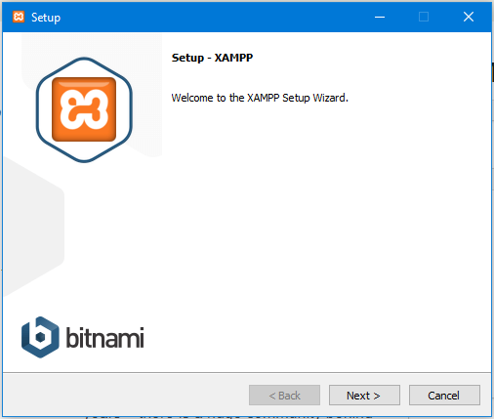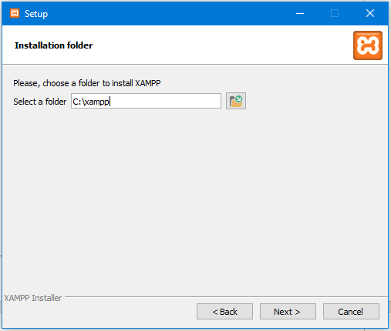

Click on the “Start” buttons circled in red to initiate and connect the servers.

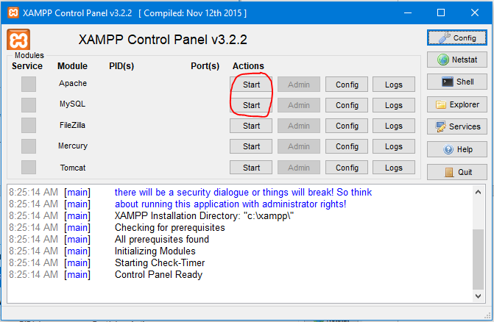

Check the status window for any errors and to confirm MySQL and Apache servers are connected and running.

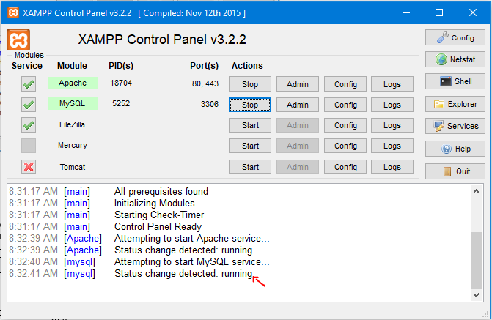

SQL Server Configuration:

Open the MySQL admin page by clicking the “Admin” button circled in red below.

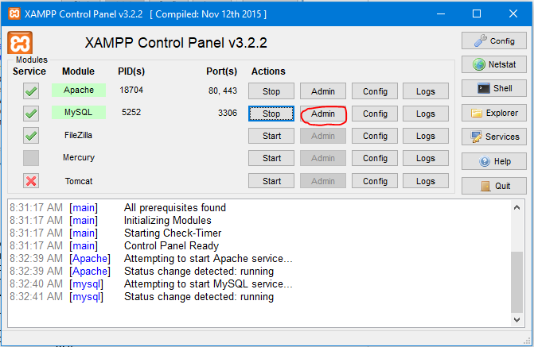

This is the MySQL database configuration page. Import of Travel Experts SQL database can be achieve through this configuration page.

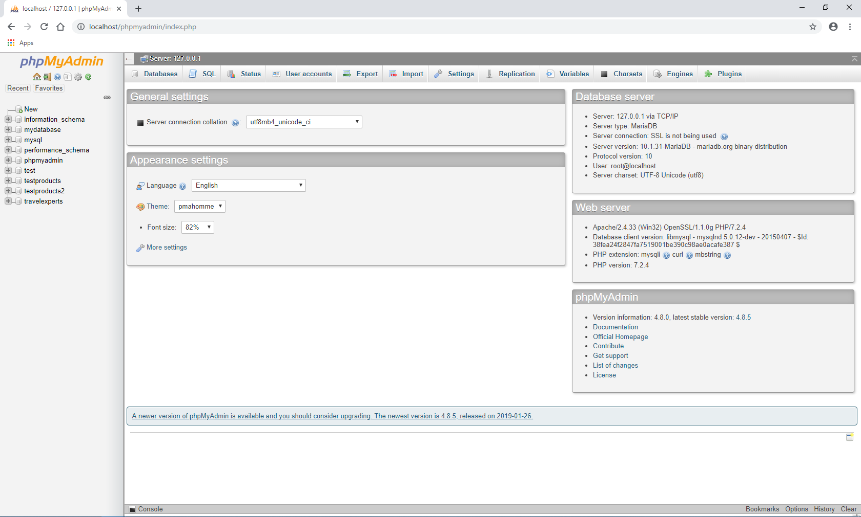

Click on the import tab circled in red below. It brings you to a page which allows you to select and import a .sql file then add it to this MySQL database.

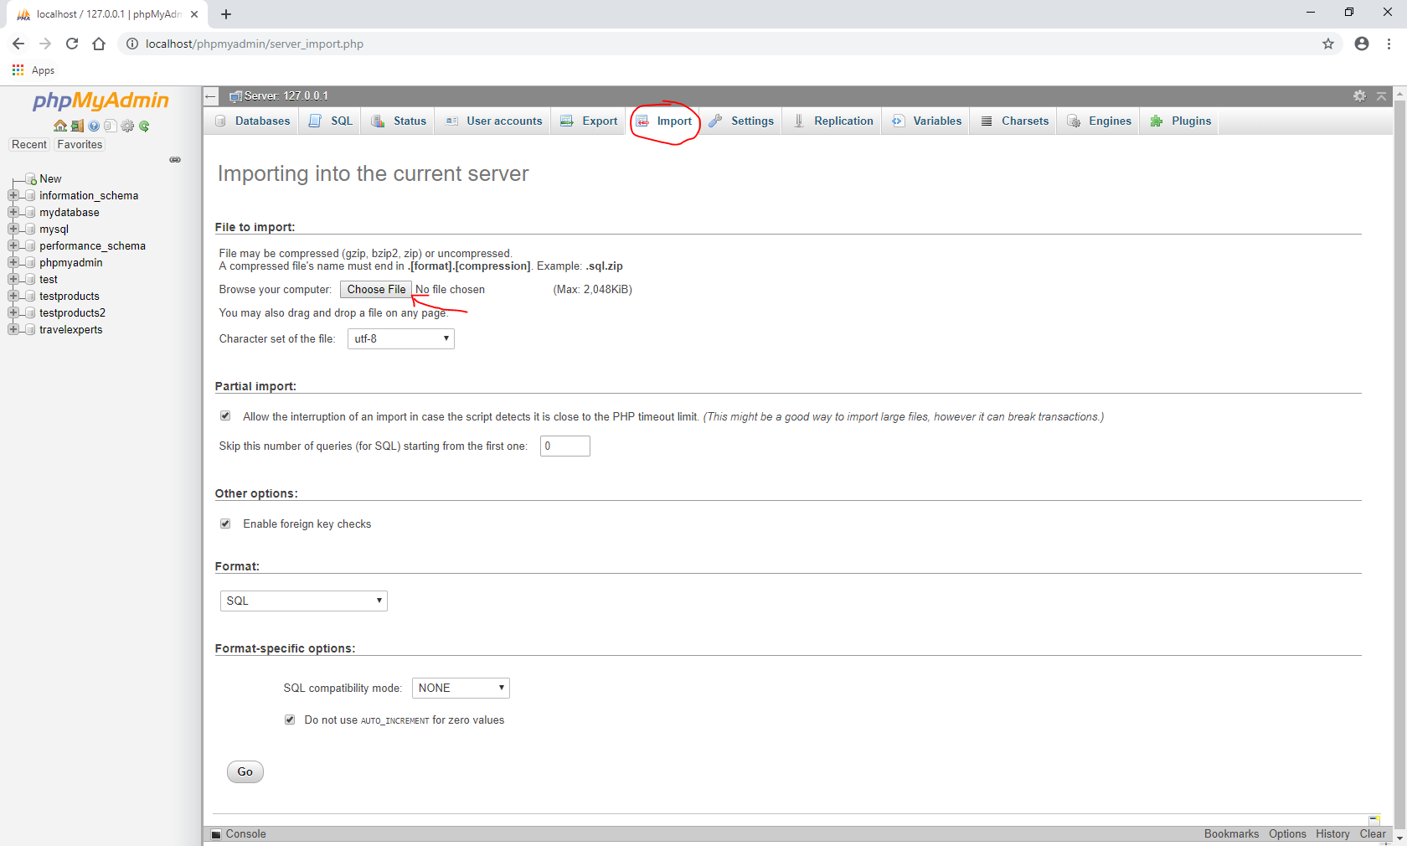

Locate the “travelexperts.sql” file zipped in the “travelexperts.zip” file. Select and click “Go” to import Travel Experts database to MySQL server.

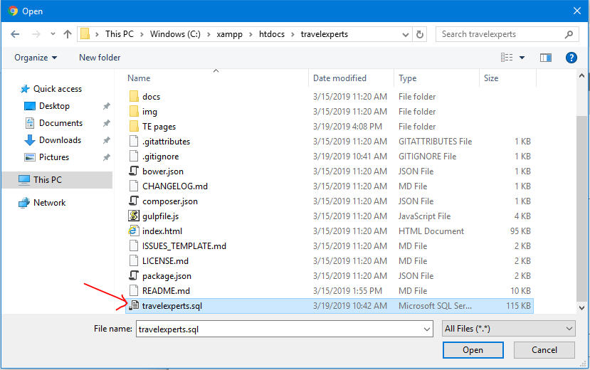

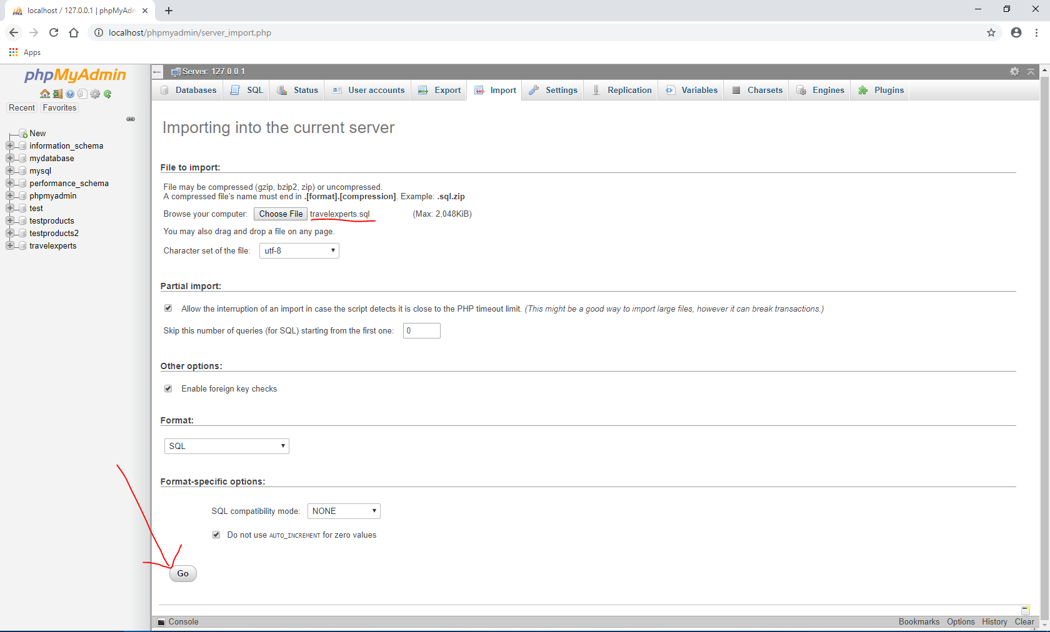

Successful database imports. The DB will appear in the database tree on the left side of the page.

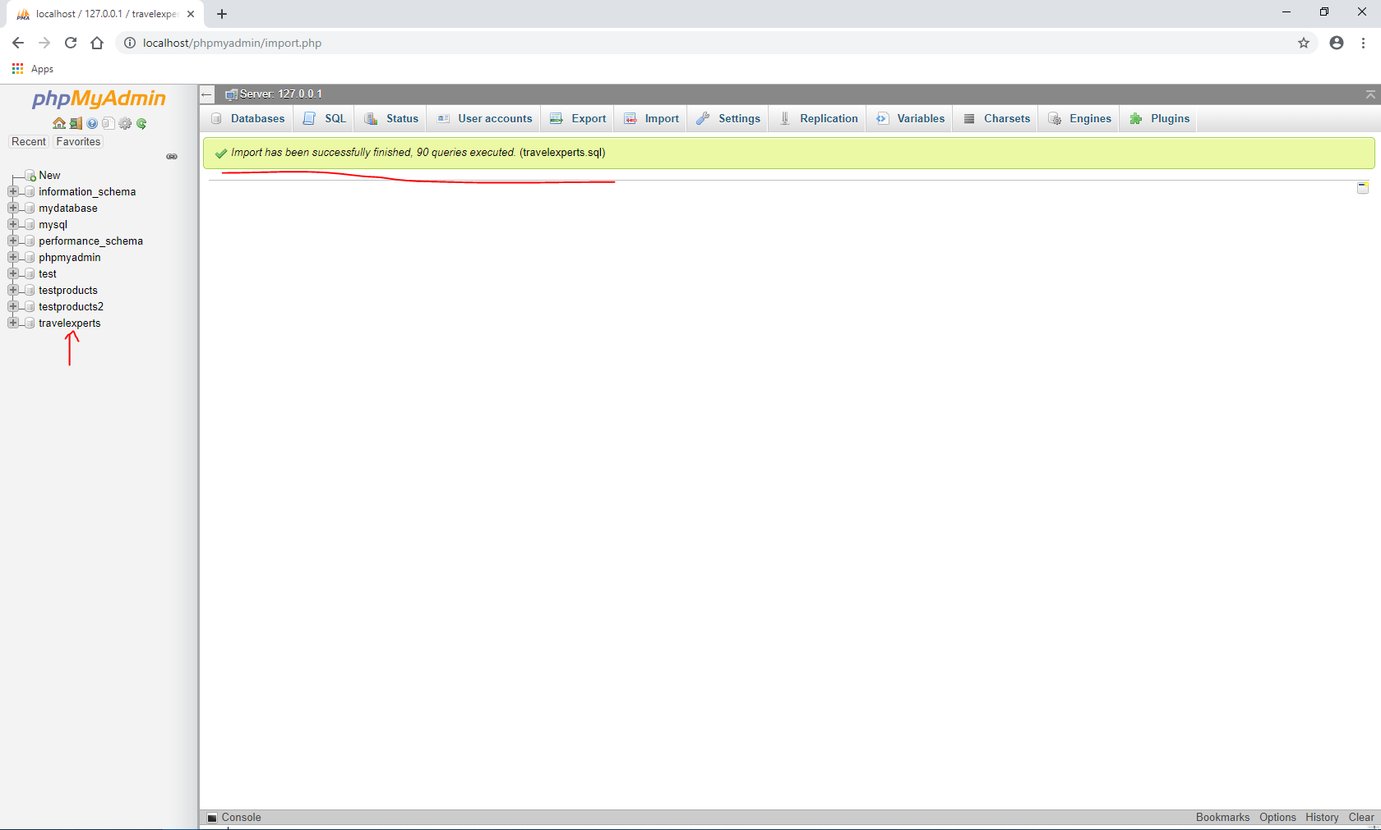

Open the database tree to find all tables attributed to Travel Experts database.

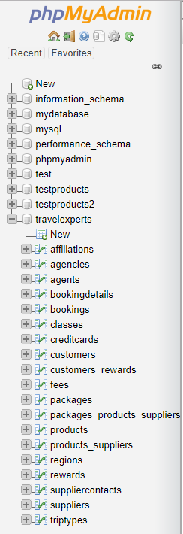

In the database, click on the “Privileges” tab circled in red below to bring you to the user access page.

Click “Add user account” to add a user that has access to use and modify the Travel Experts database.

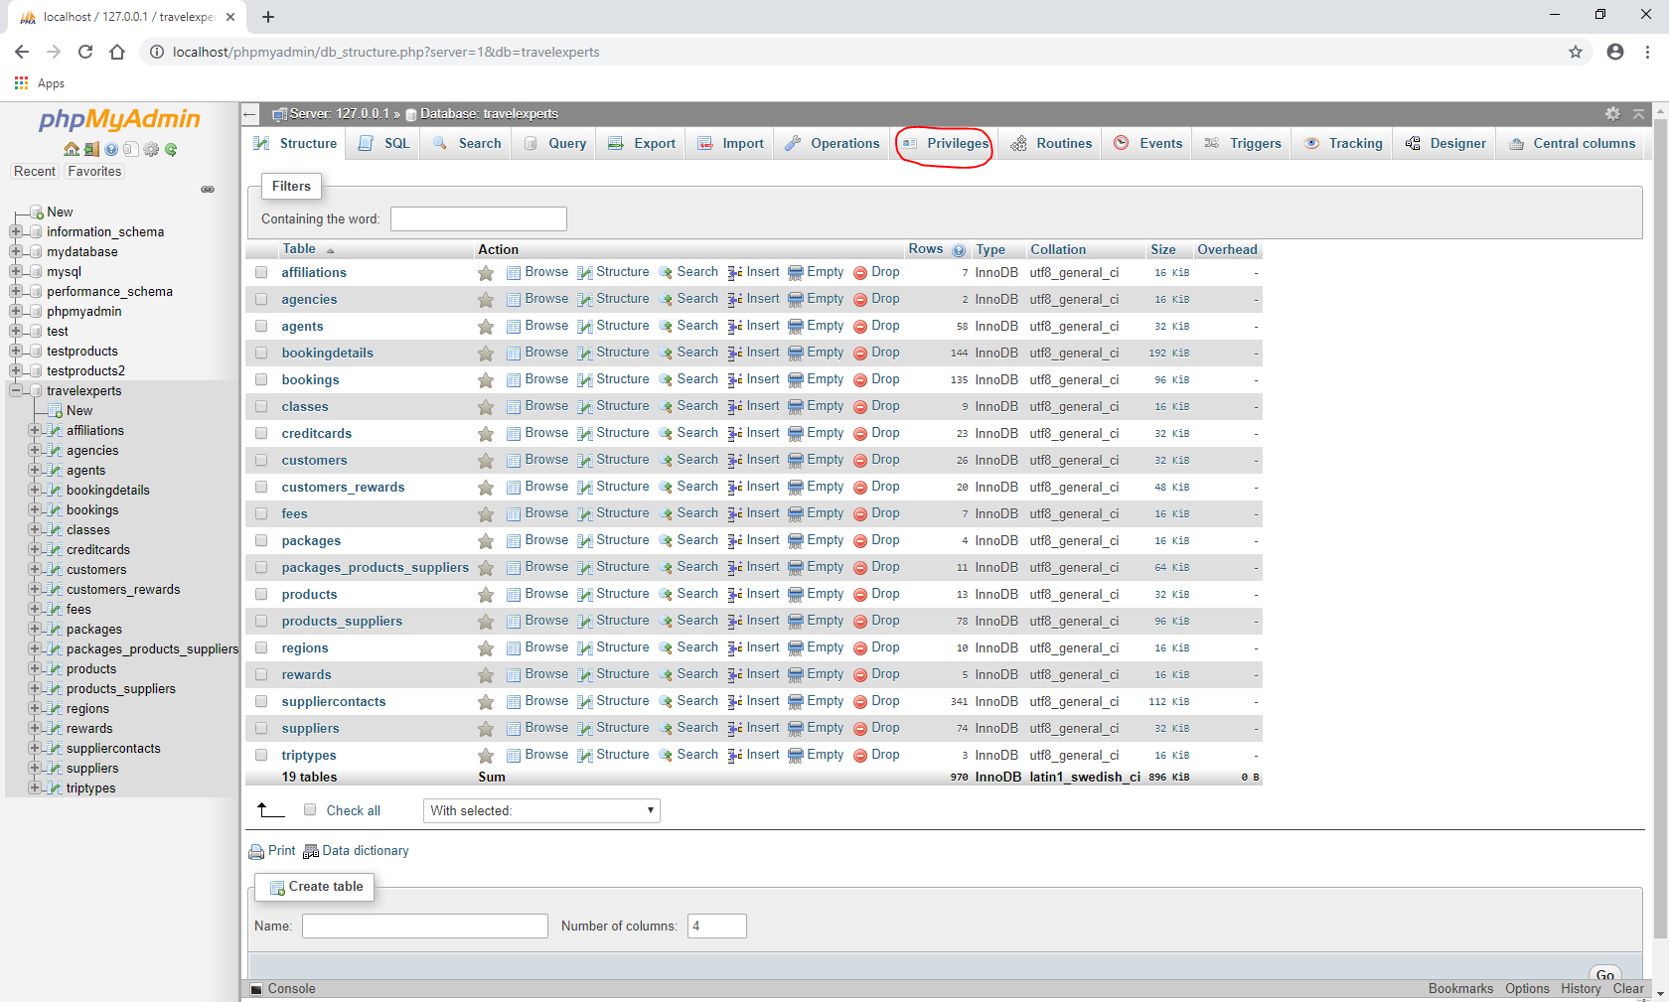

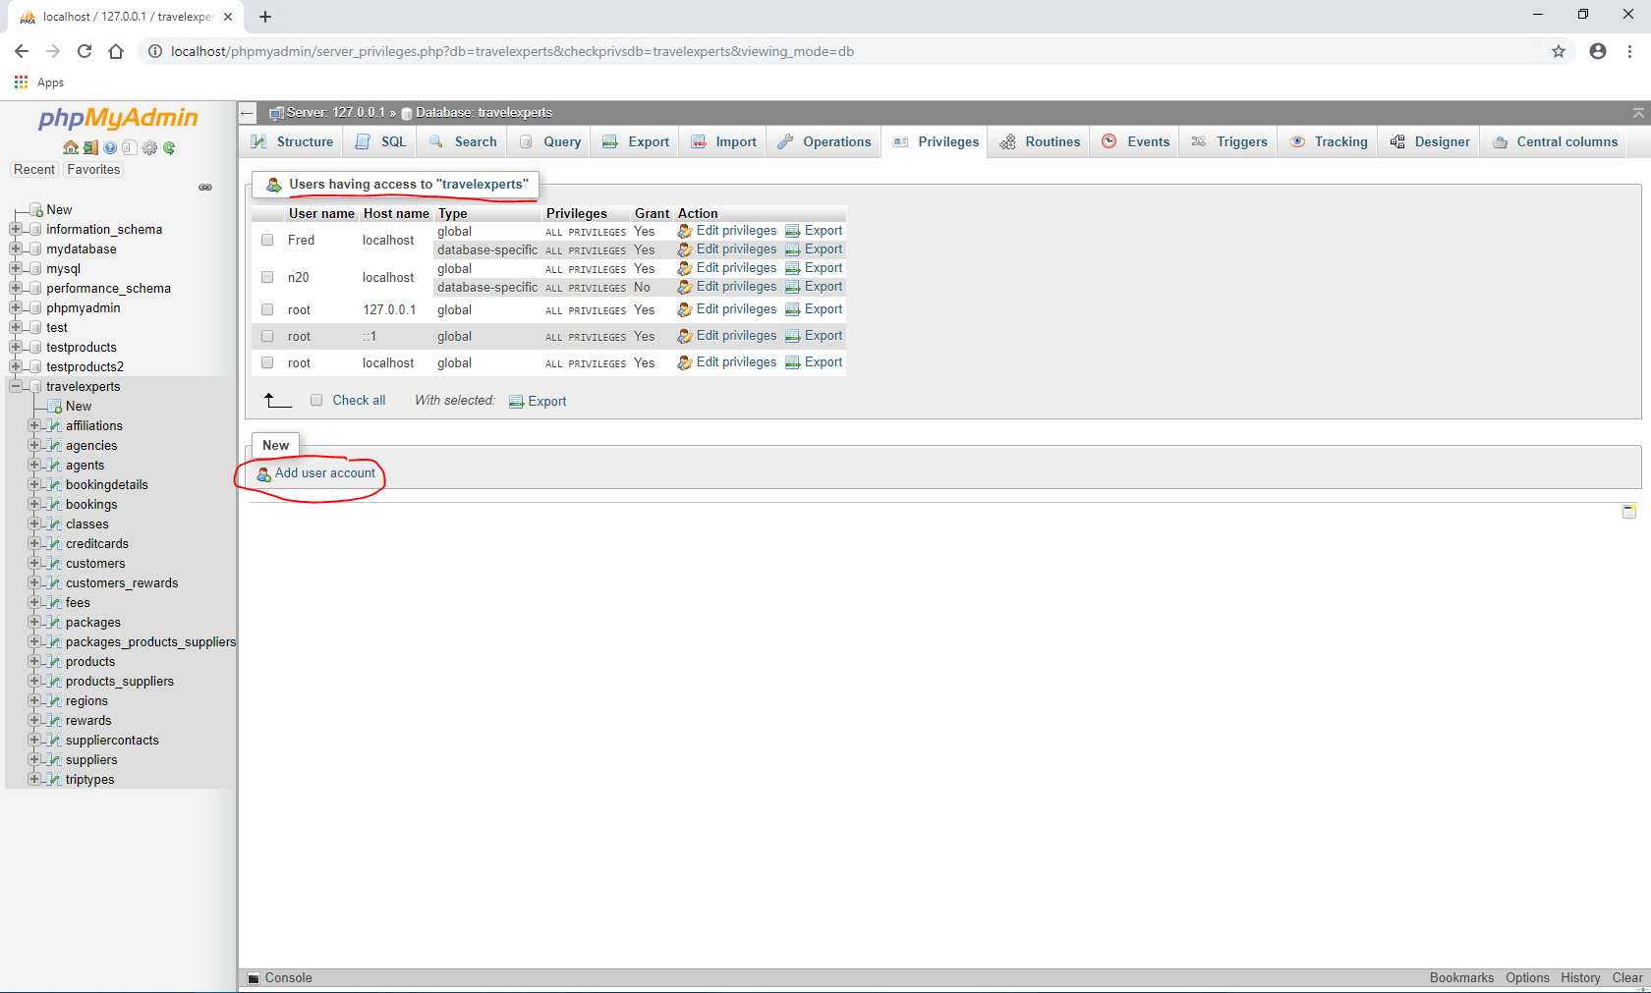

Use login, password data, and hostname in section 2.1.2. Grant “Data” and “Structure” privileges and click “Go” to initiate.

The database is now configured for web application connection and data usage.

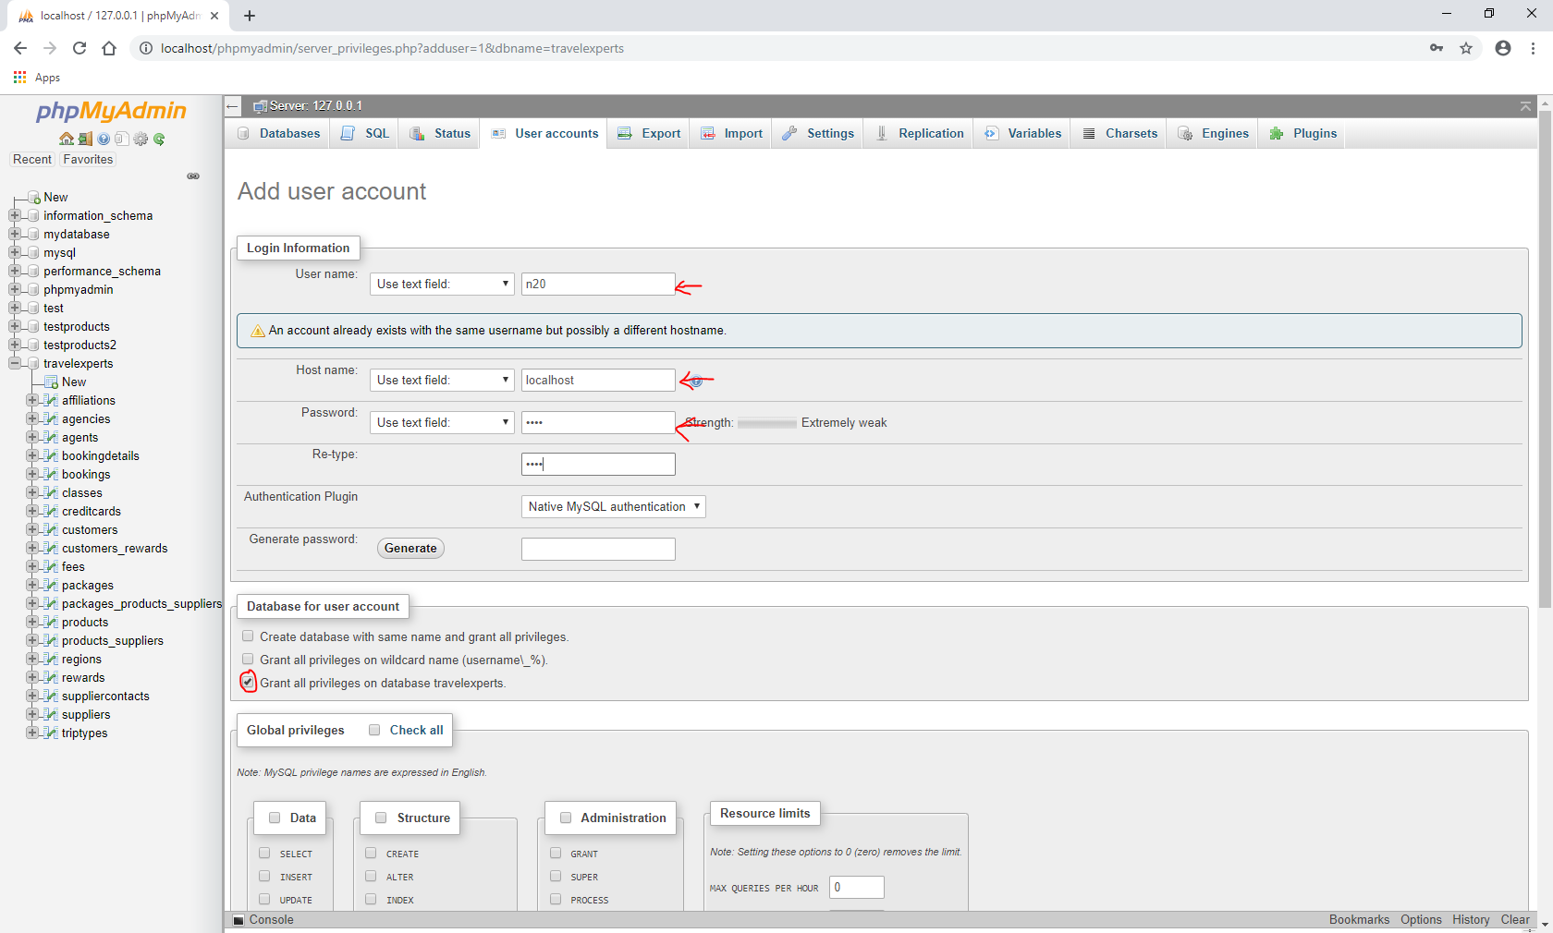

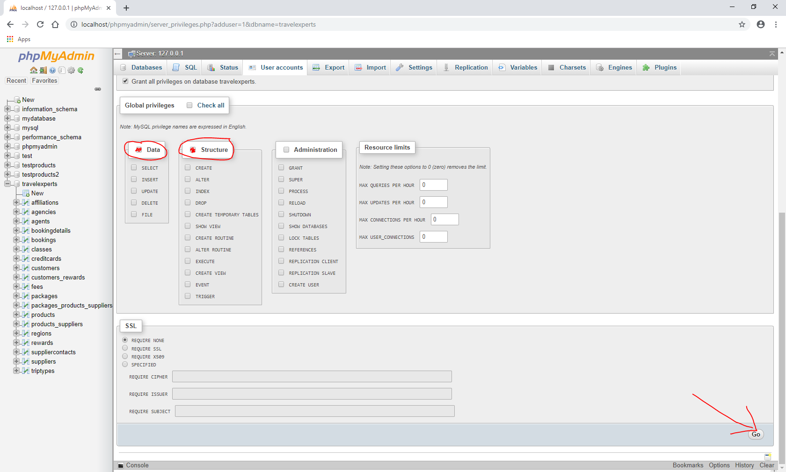

### Configured Values

Use the table below to make note of the values for your installation environment for future reference. (Note: recording of information throughout should be in keeping with your local policies for system documentation and password security).

| Information | Value |
| --- | --- |
| Server name | Localhost |
| SQL instance name | travelexperts.sql |
| SQL Server Administrator account name | n20 |
| SQL Server Administrator account password | 0000 |

## Server 2 (Web Application)

The Apache server is configured by default to serve out pages contained in the “htdocs” folder. Add the “travelexperts.zip” file and unzip into the folder.

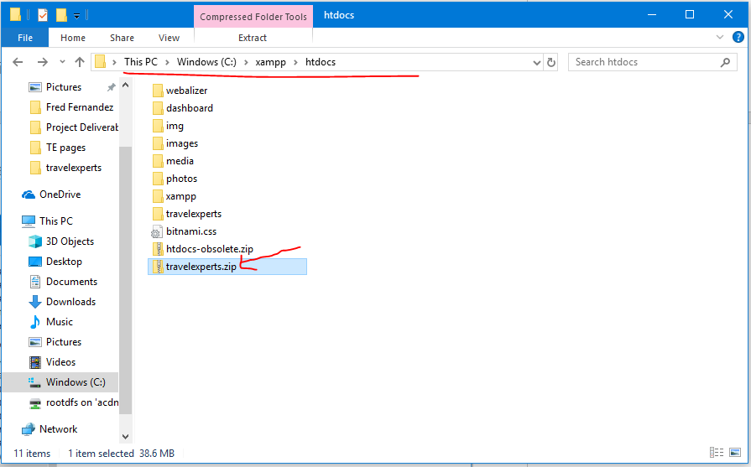

This folder is now ready to be served by the Apache server.

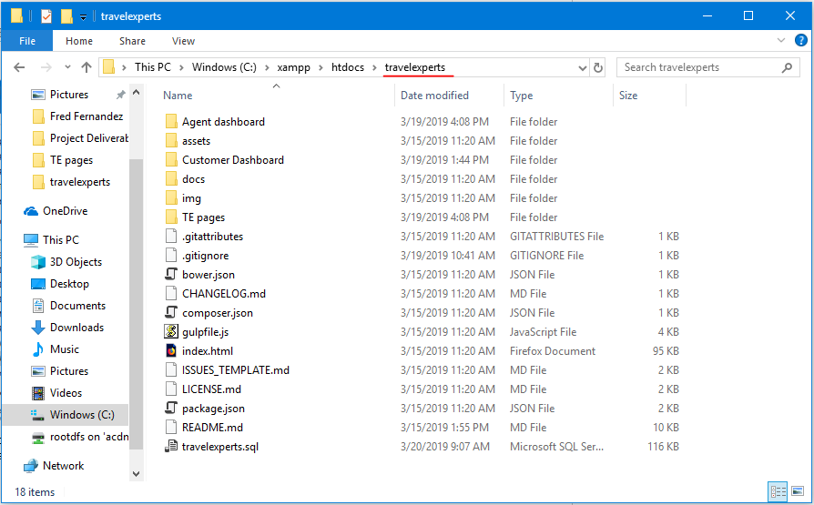

# Testing the Website

Navigate your web browser to the Host Name you noted in section 2.1.2.



Alternatively, use your IP address to connect to localhost. Ex: [http://localhost\travelexperts\TE%20pages\landing.php](http://localhost/travelexperts/TE%20pages/landing.php)

The webpage is now ready to be viewed and navigated!



# Troubleshooting

1. Where is the SQL file?
   1. The database file, “travelexperts.sql” is located in the zip file “travelexperts.zip”. Unpack or open and extract the travelexperts.sql file.
2. This site can’t be reached, localhost refused to connect.
   1. The Apache is not serving out the page. Check if Apache server is connected and running.
3. Why is the _____ page not loading?
   1. If the Apache server is connected and running, make sure the directory path is spelled properly.

1. RACI stands for: R – Responsible - "the doer - primary author"; A – Accountable - "the buck stops here" - reviews for completeness and correctness; C – Consulted - "stakeholder - invited to provide input"; I – Informed - "gets the information"